Hello Everyone!

We have incorporated the **Postman Student Expert Certification** into our syllabus, under the assignment component and will be evaluated for **10 marks.** It is compulsory to complete this certification to be eligible for the course completion certificate and this is an individual task.

**About the Postman Student Expert Certification:**

The Postman Student Expert Certification is designed to enhance your knowledge and skills in API development and testing using the Postman platform. It's a fantastic way to gain hands-on experience with industry-standard tools.

**Important Deadline:**

Please note that the deadline to complete this certification is **September 29, 2023.** Make sure to mark this date on your calendar!

**How to Register and Access the Certification Program:**

To get started, you can register and access the Student Expert Certification program by following this link

<https://www.postman.com/student-program/student-expert/>

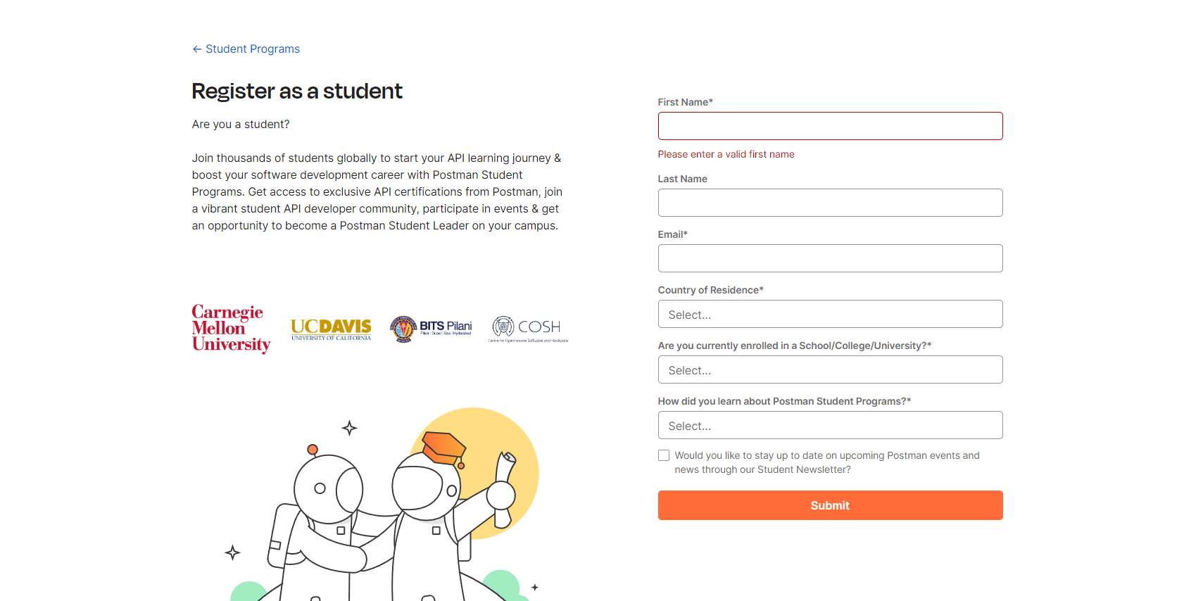

*I will share the submission links for your certificates at a later date.*

Don't miss this opportunity to enhance your skills and earn those 10 marks. Feel free to reach out to me if you have any questions or need assistance. Let's make the most of this learning experience!

Regards,

**Sarthak S Kumar**

SME - PESU I/O Slot 16